

**DocExtractor Utility for SharePoint**

Version 1.0.0.0

*Developed by: Eng. Ibraheem A. Ibraheem, 2012*

*SharePoint-Iraq Team*

**Description**:

A criteria–based mass file downloader for SharePoint for archival purposes, where we can download all or some of the data files based on wide range of user-defined criteria.

All lists and libraries (including hidden ones) will be searched, and the following will be downloaded:

* Last checked-in version of each file
* List attachments

**How to use**:

1. A User (with Site Collection Administration permissions) selects the desired Web Application and Site Collection URL.

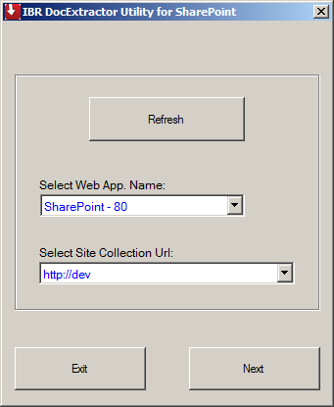

1. User can select to download all files with 2 options:
2. Download everything: to download all filed on the site collection without exception,
3. Or to specify desired criteria: such as selecting target site, user and his role, file type, file size, file date, and what text in title.

*Example: we want to download only MS Word files on Operations site that was created by Ahmed on the period between Sep 1, 2012 and Dec 31, 2012.*

Files can be downloaded alone or with the original folders hierarchy.

Before download files user must select a specified directory on the local file system to download files and folder into.

Hit the ‘Download Files’ button to start downloading.

Note: if output directory already contains files and folders, then a warning message will alert the user, with the option to continue with the download or to cancel.

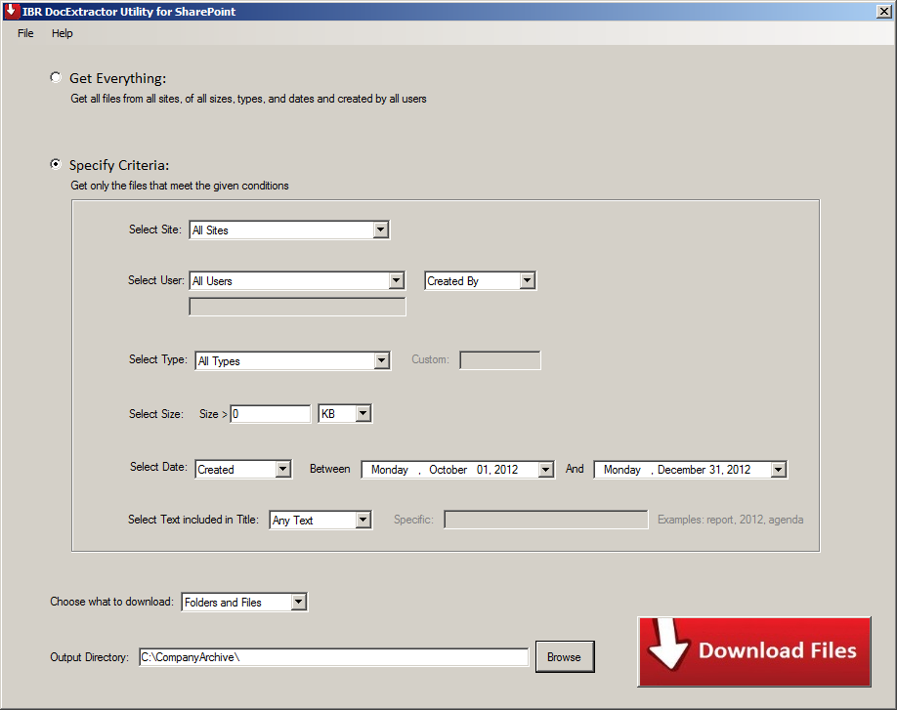

1. While downloading, user can cancel the operation at any time. 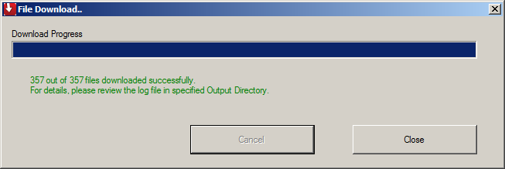

User will see notifications about the download in multiple colors to indicate status:

* **Green**: download finished successfully
* **Blue**: download was able to download files but was interrupted
* **Red**: download encounters an error

Notes:

1. if ‘Files only’ option was selected instead of ‘Files and Folders’ in step 2 above, then the tool will rename file copies automatically on the output directory.
2. Download is subject to blocked files constraint.
3. Empty folders will not be downloaded
4. After download operation is completed, a log file in the specified directory is created to show all the download details and errors if any.

File name format: “_DocExtractor Log_Date”.

